
FY 25 (July 1, 2024 - June 30, 2025) Report to the Community

FY 25 Board of Directors
Ladena Lambert President
Cody Kay
Vice President
Abby Haughee Secretary/Treasurer
Ed Dowd Director
Diane Kauffman Director
Judith Lidy Director
Terry Ramsey Director
Kathy Schmitz Director
Margie Swensen Director

Leadership Team
Joey King Executive Director
Megan Bennett Director of
Outpatient Services

Andrew Bunyard Director of Community Support Services

Mandy Bute Human Resources Coordinator

Angela Catalano
Director of Crisis
Services

Angie Sowers Director of Access and Compliance
Sarah Gracey Chief Financial Officer

A word from Our Executive Director,
Joey King
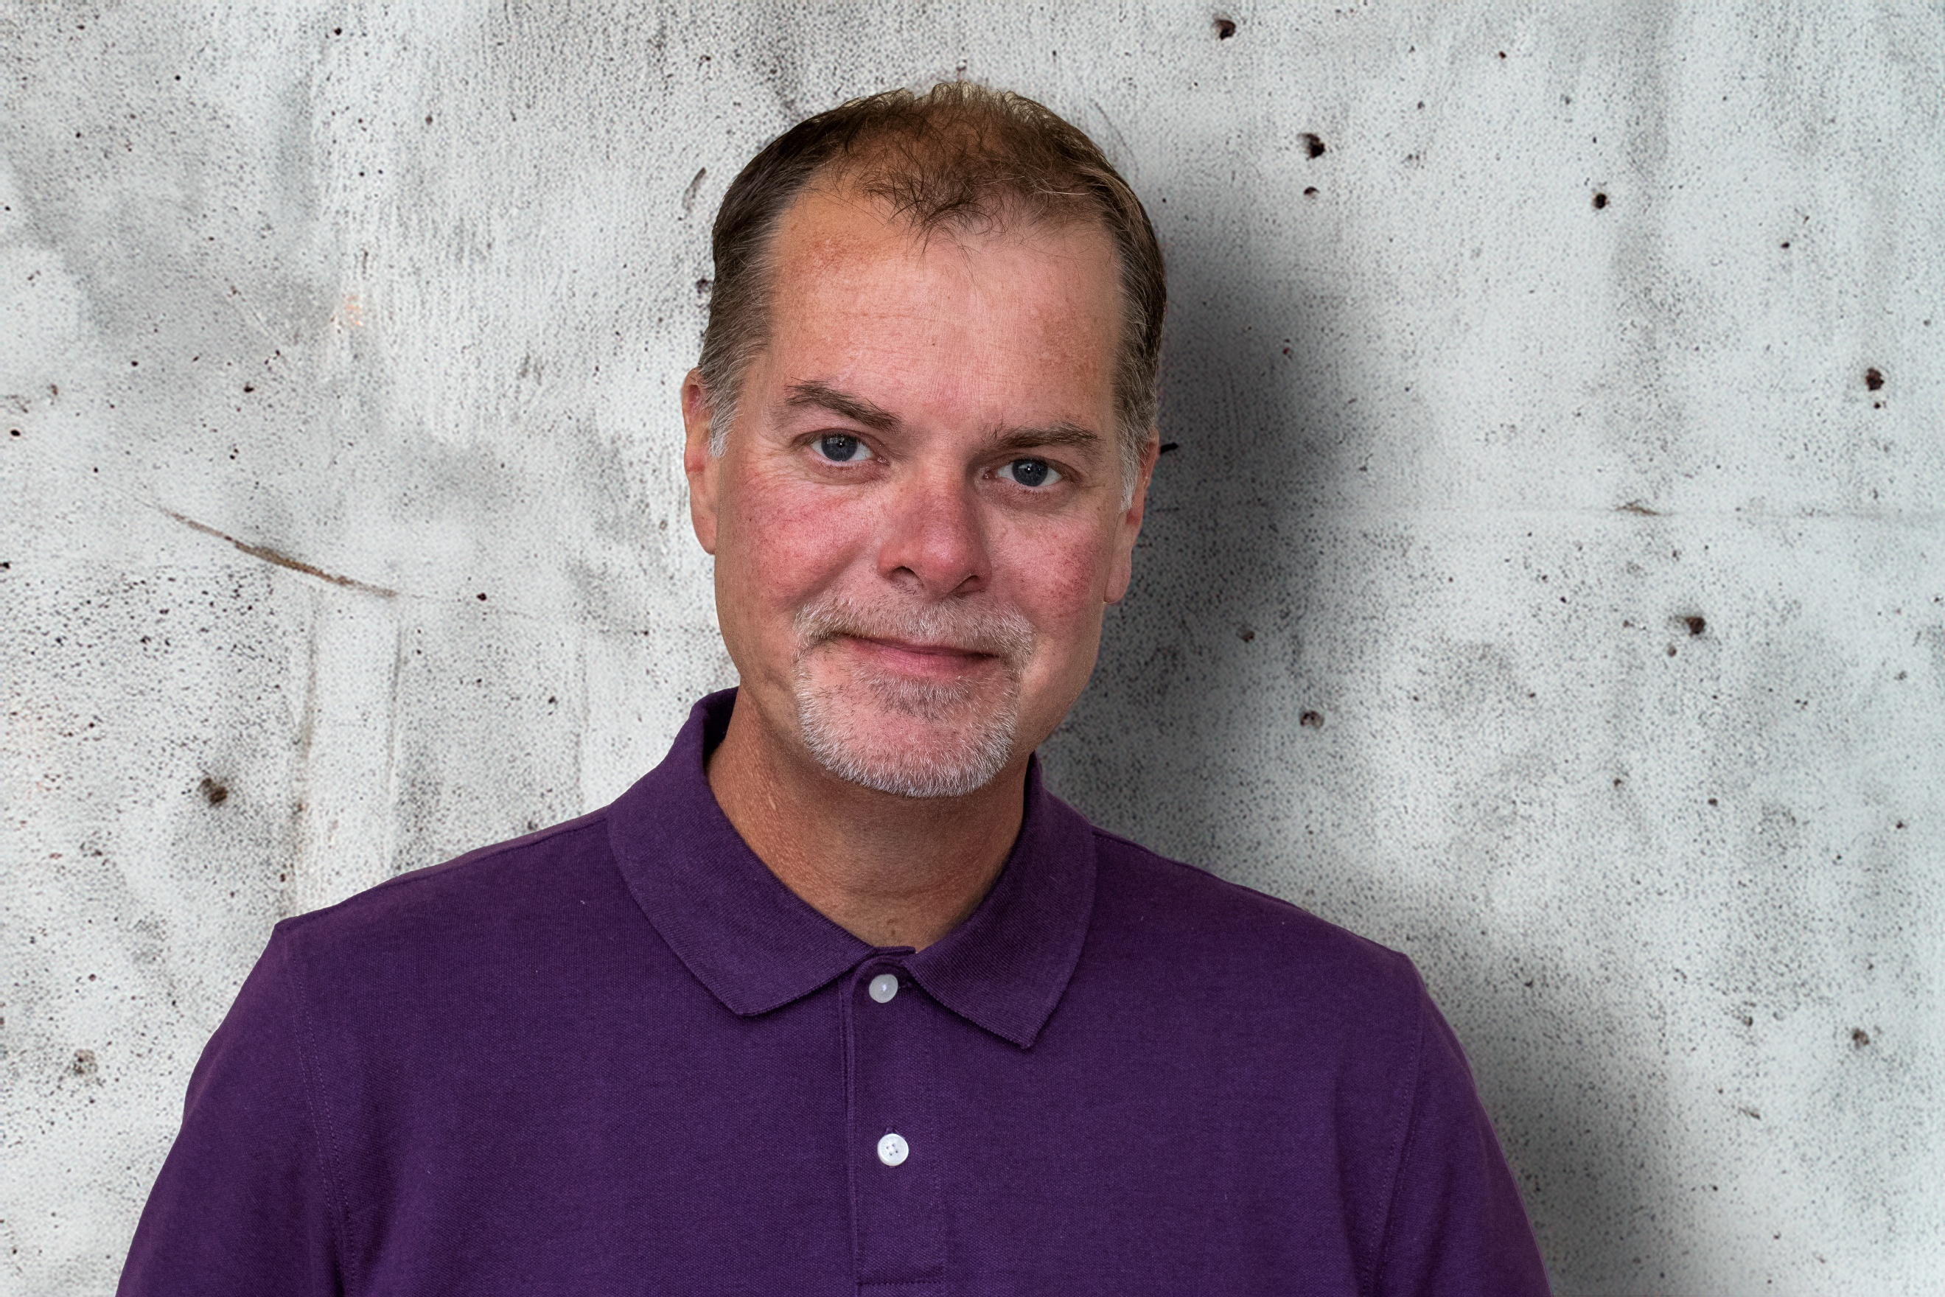

This past year has underscored, more than ever, the importance of accessible and compassionate mental health care. Across our community, we continue to see the profound impact of stress, trauma, and social isolation on individuals and families. Mental health challenges affect every age group, every neighborhood, and every profession. Resilience and recovery become possible when communities provide the right support.
At LifeLinks Mental Health we remain dedicated to ensuring that no one faces these challenges alone. Our programs and services are designed to meet people where they are — whether that means providing crisis interventions, ongoing therapy, intensive case management services, or group counseling. Over the past year, our team has expanded mobile crisis response services and crisis walk-in center, increased the services of community case management services, and supported thousands of individuals on their path to wellness.
Still, the need is growing. Too many in our community face obstacles in accessing care. Together — with your partnership, advocacy, and support — we can strengthen the safety net and create a healthier, more resilient community for all.
Thank you for standing with us in this mission. Your continued trust and commitment make this work possible.

LifeLinks provided $589,024 in free and reduced care during FY25

LifeLinks served 3,767 individuals including 947 children and adolescents!

Our mission to provide accessible, compassionate, and effective mental health care extends beyond crisis response. In FY 25 we continued to strengthen our community support services, ensuring that individuals have access to programs that promote recovery, resilience, and long-term stability.
Connections:

Community Support Services

During the past two years, LifeLinks has prioritized advancing the Connections program to provide stronger, more effective group counseling support. Over the past two years, the number of group counseling participants has increased by 31% with groups covering a variety of topics, including anxiety, depression, trauma recovery, and social skills. In addition, group members have taken part in weekly community outings, which have supported positive mental health outcomes.
Our First Episode of Psychosis program provided support to individuals navigating their initial experience with psychosis. Through early intervention, 100% of participants remained engaged in school or work within six months of entering the program. Families also received education and support, with many reporting increased confidence in understanding symptoms and supporting their loved one’s recovery.
Through the Individual Placement and Support program, individuals explored job opportunities in a variety of fields, from retail and food service to skilled trades and office administration. With 82% of employed participants not only meeting but consistently exceeding their goals, it’s clear that the right supports open the door to both meaningful work and long-term success.
Together, these programs illustrate our commitment to providing mental health care but also providing the ongoing supports that help individuals thrive, reclaim independence, and connect with their community.
Mobile Crisis Response Services

In the past year, our community faced an unprecedented demand for urgent mental health support. We provided many crisis interventions, ensuring that individuals in immediate distress were met with compassion, safety, and timely care.
Every day, people in our community experience acute mental health challenges — from overwhelming anxiety and depression to suicidal thoughts or the aftermath of trauma. In moments of crisis, access to immediate help can mean the difference between stabilization and escalation. Without these resources, many would be left to navigate emergency rooms, law enforcement, or unsafe situations on their own.
Our mobile crisis team brings expert care directly to where it is needed most. Whether at a home, school, workplace, or community setting, this team de-escalates situations, connects individuals with appropriate services, and reduces unnecessary hospitalizations and arrests. Last year, our mobile crisis units responded to 6,116 crisis interventions providing life-saving support in real time. Out of the 6,116 interventions 2,041 of the interventions were in person mobile crisis response services.
Our mission is to design and deliver an array of high-quality, cost-effective outpatient behavioral health services oriented toward consumer recovery & responsive to the needs of the consumers, their families & the community.
For those that desired to seek help in person, our Crisis Walk-In Center offered immediate, face-to-face support in a safe and welcoming environment. The center provided rapid assessment, stabilization, and connections to ongoing care. In total, 109 individuals accessed help through the walk-in center — many of whom might otherwise have gone without support.
The growing demand for crisis services reflects both the rising mental health needs in our community and the confidence people have in these supports. By expanding mobile response and strengthening the walk-in center, we aim to reduce barriers to care and ensure that every person in crisis has access to immediate, effective support.
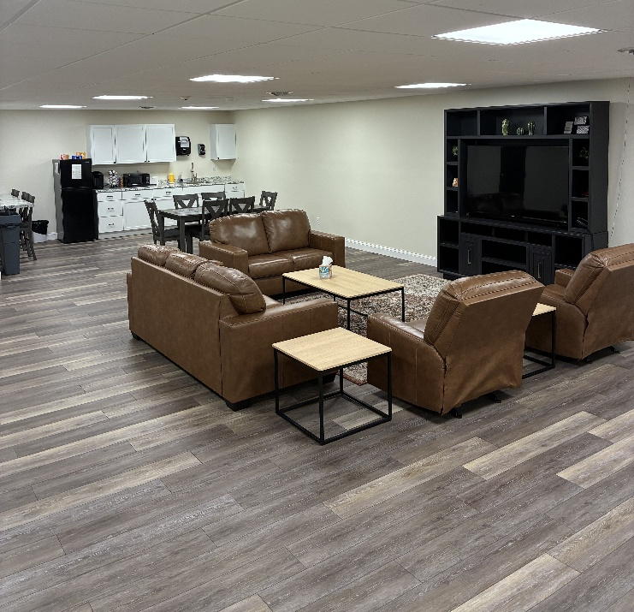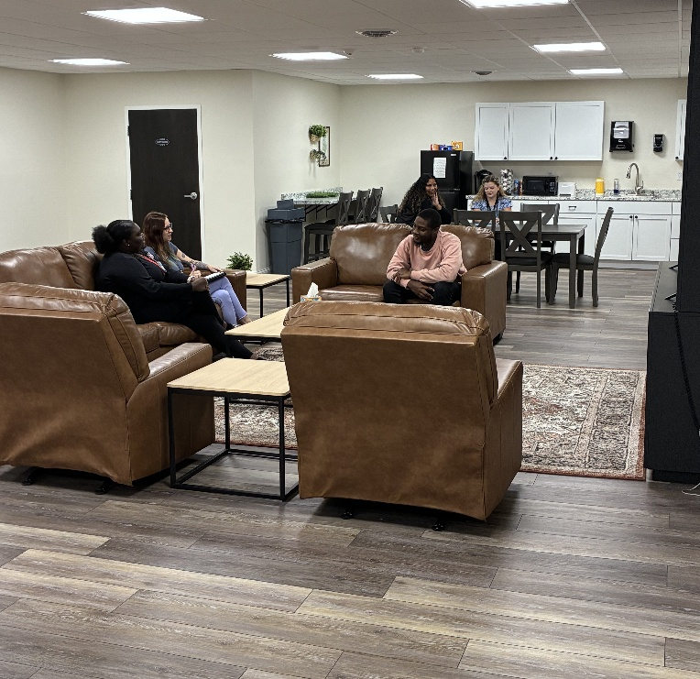

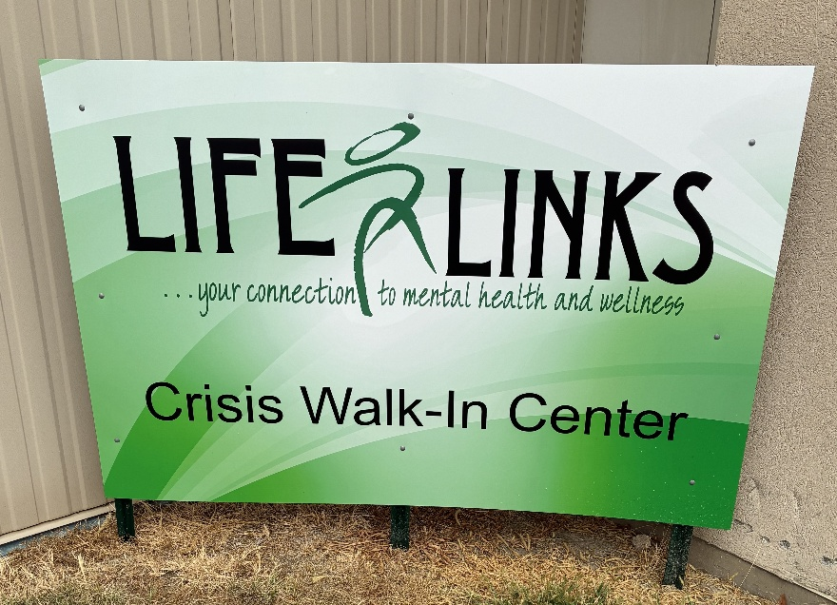
LifeLinks Crisis Walk-In Center located at 750 Broadway Avenue East. This space offers a safe, welcoming environment for community members to access free, immediate crisis intervention services.

Our mission is to design and deliver an array of high-quality, cost-effective outpatient behavioral health services oriented toward consumer recovery & responsive to the needs of the consumers, their families & the community.
Our supporters help to make all this possible.
LifeLinks is grateful to thank our donors:

Founder’s Society
$1,000 - $5,000
Howell-Adams Family Foundation
Cody Kay
Rick and Betty Reed
John and Patty Hedges
Tina and John Lauer
Ed Carter Construction Ed and Becky Carter
The Sparks Foundation
Century 21 KIMA Properties Kirk and Margie Swensen
Rural King
Special Recognition
In Memory of Richard Cook
Julie Ruffolo
In Memory of Roger Wilhelm
Cherryl Conlin
In Memory of Richard Myers
Rosalee Myers
In Memory of Rebecca
The Oakley Family Reunion Fund
In Honor of Jared
Nancy Kull-McGow
Founder’s Society
$500 - $999
Debby Cook
Cherryl Conlin
Carol and Greg Ray
Phil and Peggy Kepp
Joey and Angie King
Dr. and Mrs. Robert Good
Larry and Ardis Larvick
The UPCHURCH Group
Anamet Electrical
Jeremy and Sarah Gracey
Ladena Lambert
Terry and Christine Ward
Judy and Bob Jones
Kit Morice and Andy Gage
We appreciate your financial support for quality mental health services!

Supporters
$25 - $499
Dr. Gloria Leitschuh
Julie and Jeff Nelson
Gary and Sharon Brinkmeyer
Terry Ramsey
Rosalee Myers
Robert and Sherri Arnholt
Stephen and Judy Corn
Mark and Gail Nelson
Marion Dowd
Joe and Pam Catalano
The Oakley Family Reunion Fund
Nancy Kull-McGow
John and Donna Mayer
Dr. Mercy Eigbike
Diane Kauffman
Julie Ruffolo
Brent and Kathleen Holmes
Steve and Linda Wente
Debra Allen
Sandi Gilbert
Carla Porter
Pat Houser

